Project Design Phase -||
Data Flow Diagram & User Stories

Date | 10 AUG 2025
Team ID | PNT2025TMID12444
Project Name | Garage Management System
Maximum Marks

Data Flow Diagram:

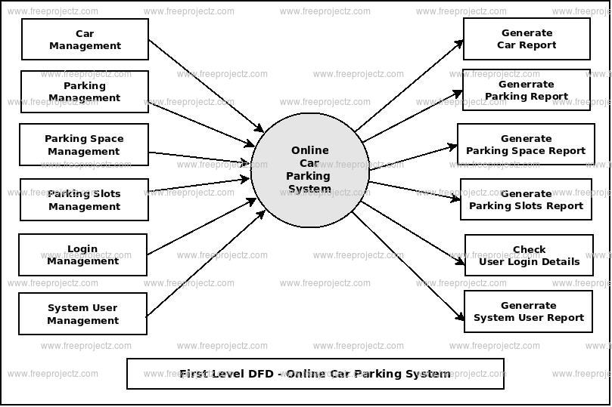

Example:
flow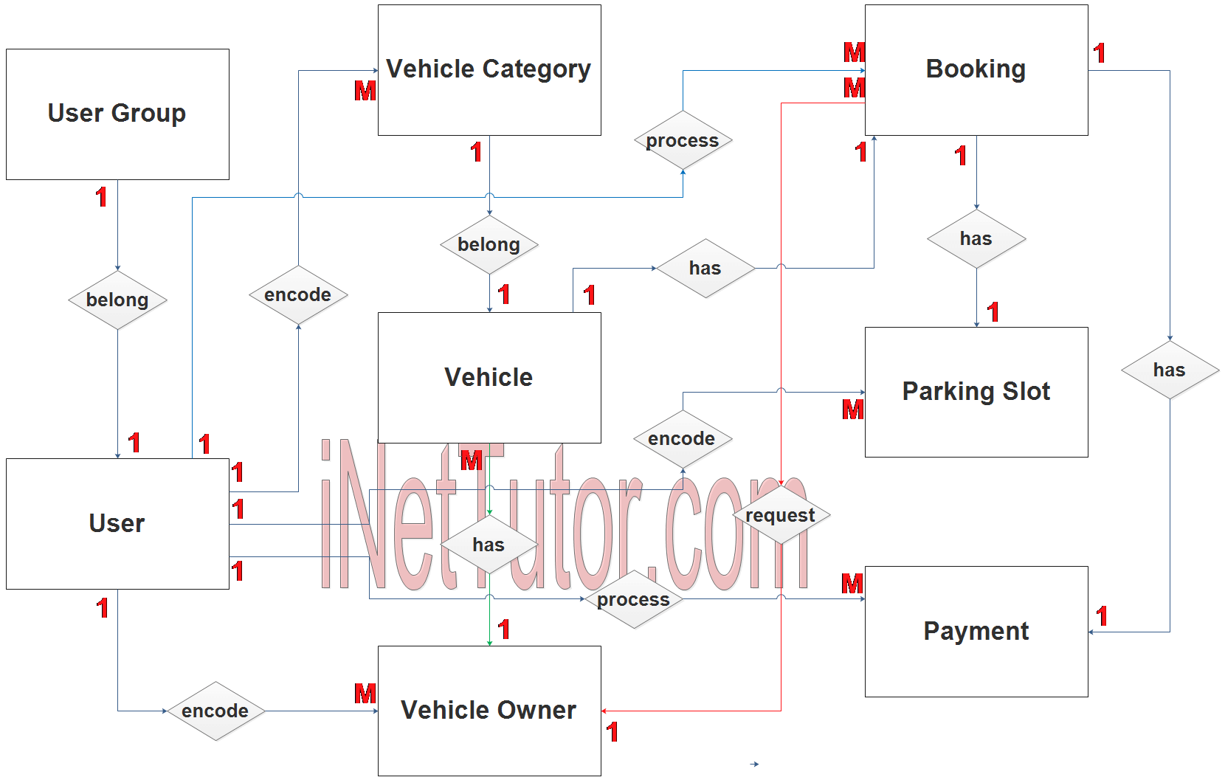

User Stories:
Customer User Stories
- As a customer, I want to book a service appointment online, so that I can avoid waiting at the garage.
- As a customer, I want to view my vehicle’s service history, so that I can track past repairs and maintenance.
- As a customer, I want to receive notifications when my vehicle is ready, so I can pick it up on time.
Mechanic/Technician User Stories
- As a mechanic, I want to see a list of assigned jobs, so I can plan my workday efficiently.
- As a mechanic, I want to update job status (e.g., In Progress, Completed), so the system reflects real-time progress.
- As a mechanic, I want to log parts used, so inventory is automatically updated.
Admin/Manager User Stories
- As an admin, I want to add or remove services, so the system reflects current offerings.
- As an admin, I want to generate invoices, so I can bill customers accurately.
- As an admin, I want to track inventory levels, so I can reorder parts before they run out.
- As an admin, I want to view reports on service trends, so I can make informed business decisions.
System/User Interface Stories
- As a user, I want to log in securely, so my data is protected.
- As a user, I want to navigate the dashboard easily, so I can find what I need without confusion.

